contact: Chris McLean
phone: +1 (778) 999-0951
fax: +1 (604) 677-5923
email: chris@espro.ca

FOR IMMEDIATE RELEASE

PLEDGE FOR THE PRESS!
Espro turns to Kickstarter to launch its newest product

Monday 5th December 2011 - Since launching the Espro™ Press last year, Espro Inc. has been overwhelmed with support from the coffee community, who love the brewer’s ability to fully express the intended flavors of single varietal coffees without leaving grit in your cup. But one cup is never enough, and the resounding question on everyone’s lips is “When will the press be available in a larger size?” The Espro team is now going big with the Espro™ Press and has turned to Kickstarter to launch the larger version.

“Product innovation and development is a big investment for a growing company like Espro,” commented Bruce Constantine, co-founder of Espro Inc. “Kickstarter offers a great way for us to involve the community in our innovation, with coffee-lovers able to pre-order the product and be the first to enjoy it. The funds raised in this campaign will literally kick-start production of the larger Espro™ Press everyone has been waiting for!”

Kickstarter is the world's largest funding platform for creative projects. Every week, tens of thousands of people pledge for products and experiences specific to each project. Espro recognized Kickstarter as a unique way to launch its newest product. There are several pledges at different price points to choose from, and this is an exclusive opportunity to pre-order the large Espro™ Press before it is released into the market early next year.

“The funding will be a significant contribution to making this new design a reality” said Chris McLean, lead designer and co-founder of Espro Inc. “Prototypes are done, designs and quotes are in. Our next step is to tool up and start production.”

The Espro™ Press is a precision coffee brewer, similar to a french press. It preserves all of the freshly brewed flavors and aromas by micro-filtering with a patent pending two-stage micro-filter, which keeps sediment out of your cup.

For more information about Espro’s Kickstarter project, see it online at http://kck.st/t3ZwHc.

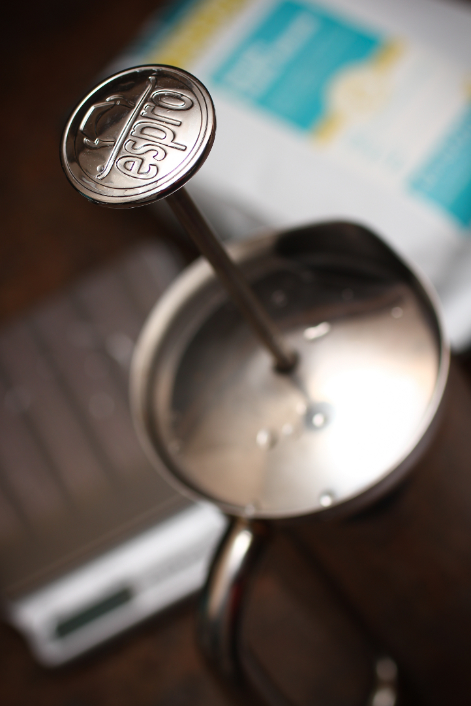
About Espro Inc.
Espro Inc. is a Vancouver based design company which has been pursuing the perfect cup of coffee for 8 years. Their precision coffee and espresso accessories take care of the science, so coffee lovers can master the art of making great coffee and espresso. Products include calibrated tampers, milk pitchers and the Espro™ Press.

For more information about Espro Inc. please visit the website http://www.espro.ca

# # #

Media Contact
If you would like more information or to schedule an interview with Espro Inc., please call Chris McLean on +1 (778) 999-0951 or email chris@espro.ca.

